Project Title: Smart Fashion Recommender Application Project Design Phase-I -Solution Fit Template

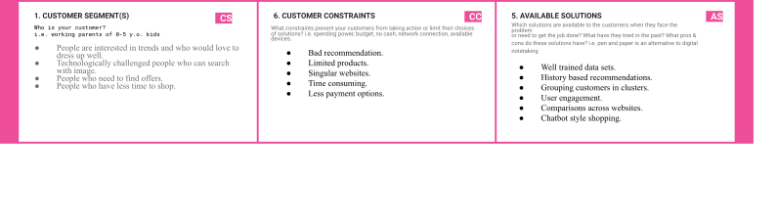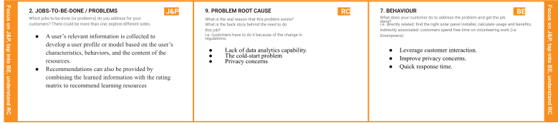

**Team ID:** PNT2022TMID050435

|  |  |  |  |  |
| --- | --- | --- | --- | --- |
| **Identify strong TR & EM** | 1. **TRIGGERS**   **TR**  What triggers customers to act? i.e. seeing their neighbor installing solar panels, reading about a more efﬁcient solution in the news.   * + The ‘discovery’ Factor   + User Engagement   + Personalized Experience | **10. YOUR SOLUTION**  **SL**  If you are working on an existing business, | 1. **CHANNELS of BEHAVIOR**   **CH**   * 1. **ONLINE**   What kind of actions do customers take online? Extract online channels from #7   * 1. **OFFLINE**   ind of actions do customers take ofﬂine? Extract channels from #7 and use them for customer  pment.   * + - Clear with want they want and choices |  |
|  | write down your current solution ﬁrst, ﬁll in |
|  | the canvas, and check how much it ﬁts |
|  | reality. |
|  | If you are working on a new business |
|  | proposition, then keep it blank until you ﬁll in |
|  | the canvas and come up with a solution that |
|  | ﬁts within customer limitations, solves a |
|  | problem and matches customer behavior. |
|  | * The user can speak with |
|  | the ChatBot directly |
| **4. EMOTIONS: BEFORE / AFTER**  **EM**  How do customers feel when they face a problem or a job and afterwards?  i.e. lost, insecure > conﬁdent, in control - use it in your communication strategy & design.   * 1. Lose interest   2. Slow Response Time |
|  | about the product rather |
|  | than having to navigate |
|  | through numerous |
|  | menus to make an |
|  | online purchase. |